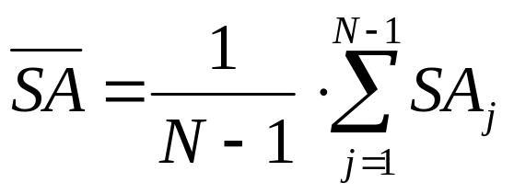 (1)

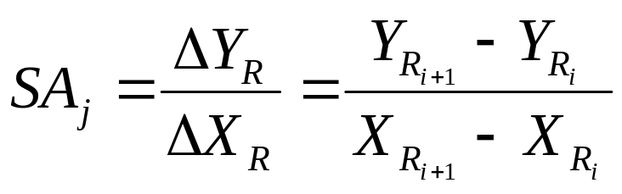 (2)

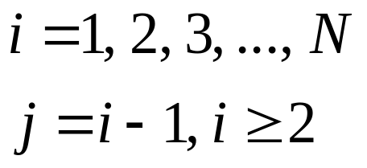

Where 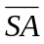 is the average sensitivity index, 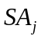is the j-th local sensitivity index, which is the slope between two adjacent points on the curve, 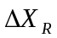is the increment of relative input variable X, 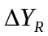is the increment of relative output Y, 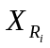and 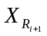are the i-th and i+1-th inputs, 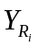and 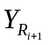are the i-th and i+1-th outputs, is the number of points (or simulation steps) on the curve.

